DBSE&DBD
DDL & DML OPERATIONS
Name: G.ROHITH
Roll: 2520030220

Screenshot 1
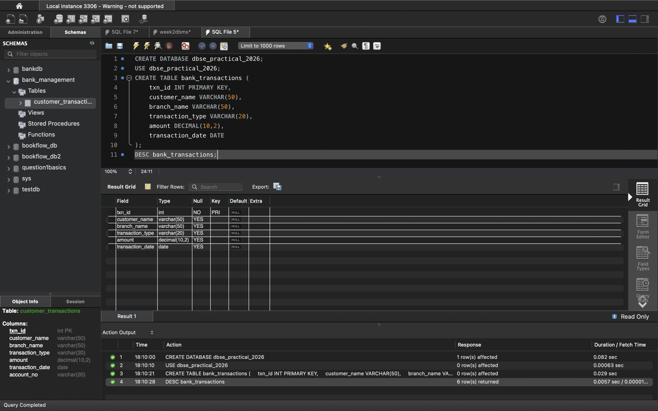

Screenshot 2
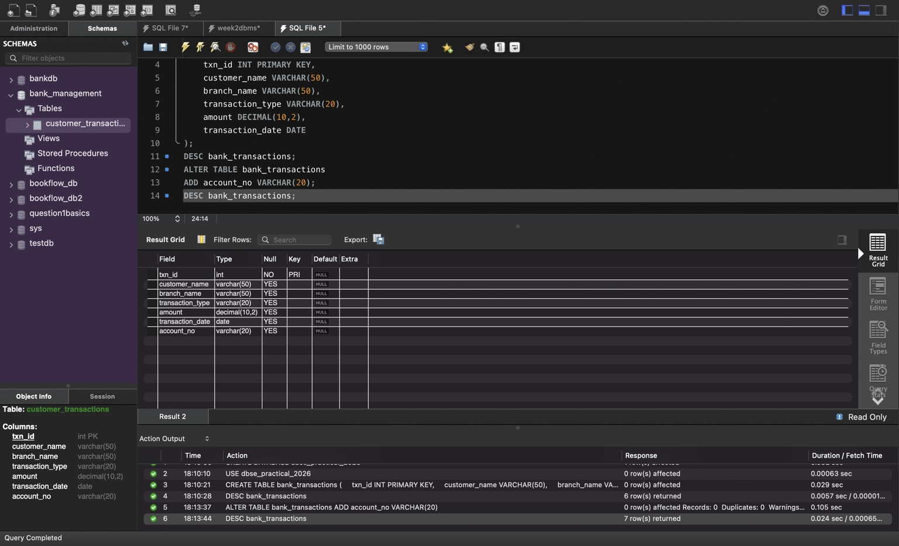

Screenshot 3
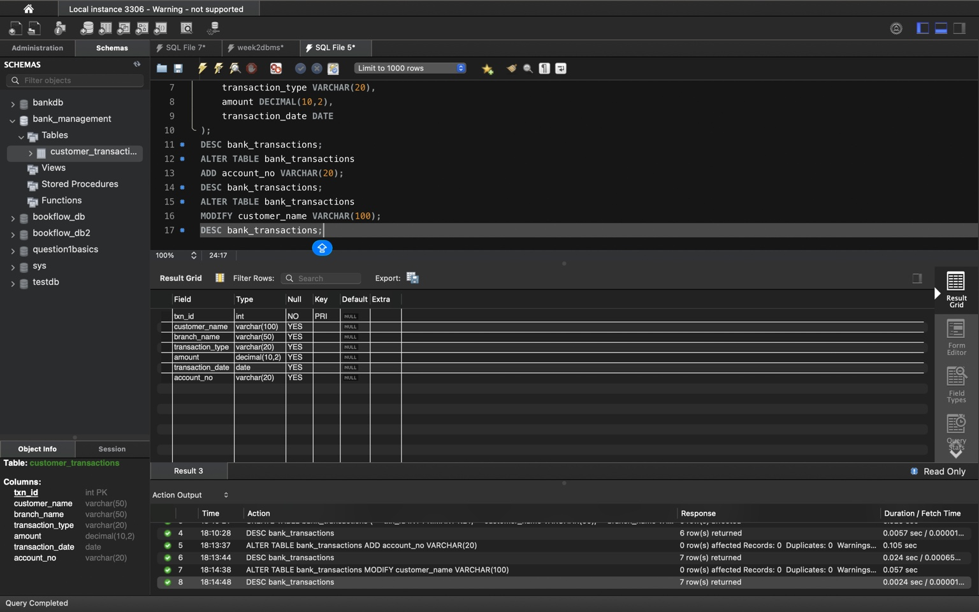

Screenshot 4
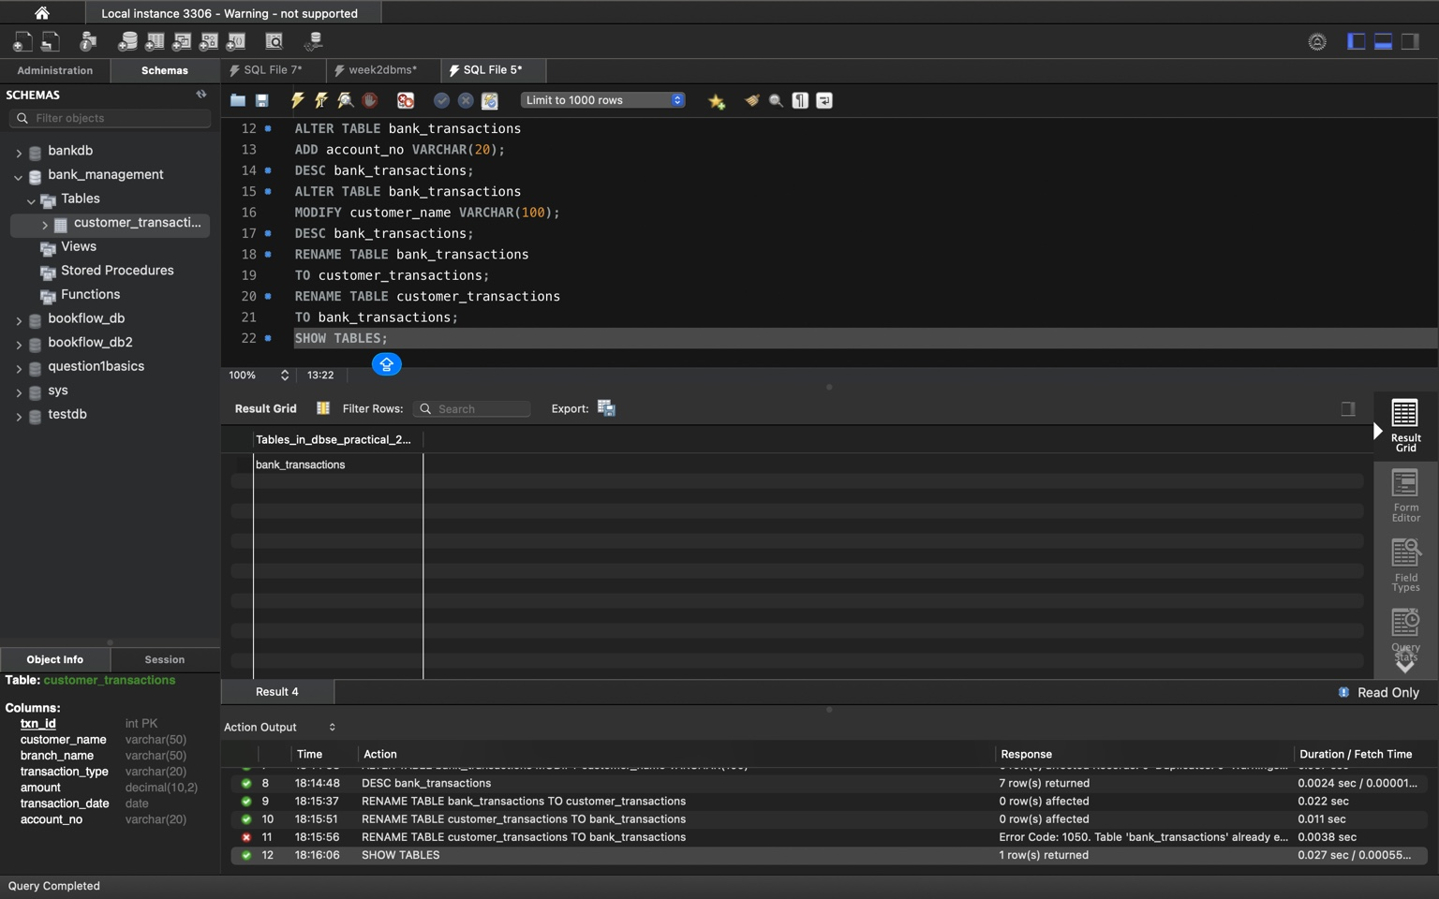

Screenshot 5
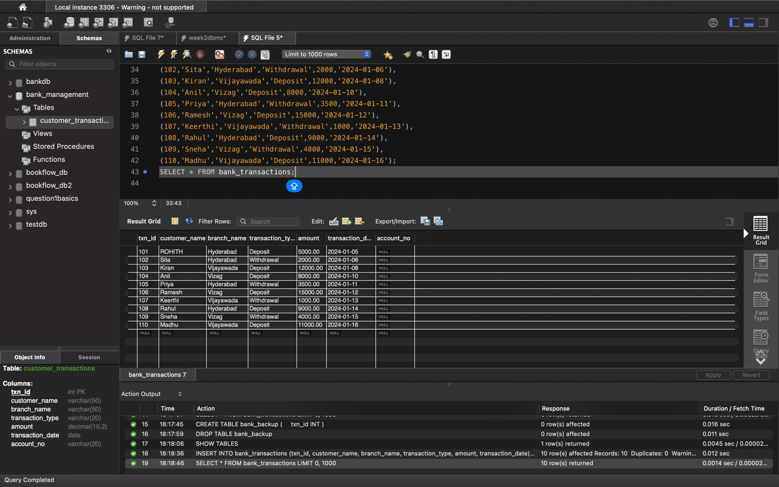

Screenshot 6
